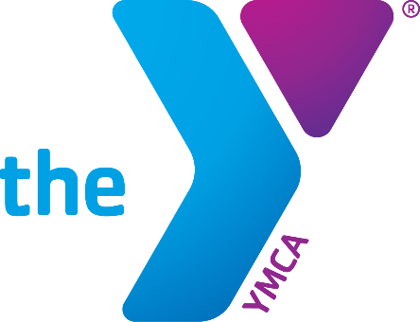
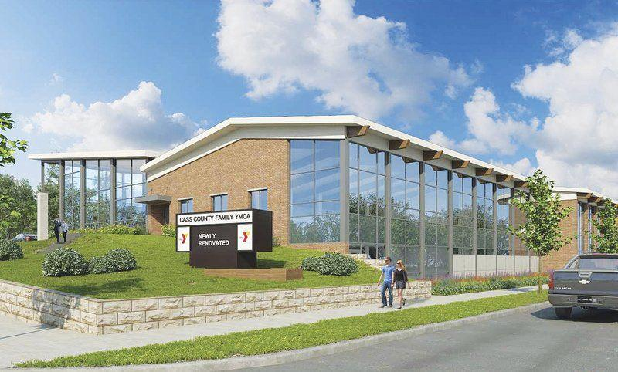

City of Logansport Employees,
Check out our newly renovated YMCA.
Get signed up today!

The City of Logansport is a Corporate Partner with the YMCA, which means all City of Logansport employees will receive Corporate Membership Prices. On top of your discount, the City has agreed to pay a portion of your membership fees.
Please stop in for a tour and see what we have to offer.

For more information, please contact Nicole Braun at 574 753-5141 or at
nicole.braun@casscountyymca.org

