- Go to https://permitting.schneidergis.com/
- Select Indiana under “state” and select City of Logansport under “jurisdiction” which will take you to the screen below.
- Select Indiana under “state” and select City of Logansport under “jurisdiction” which will take you to the screen below.
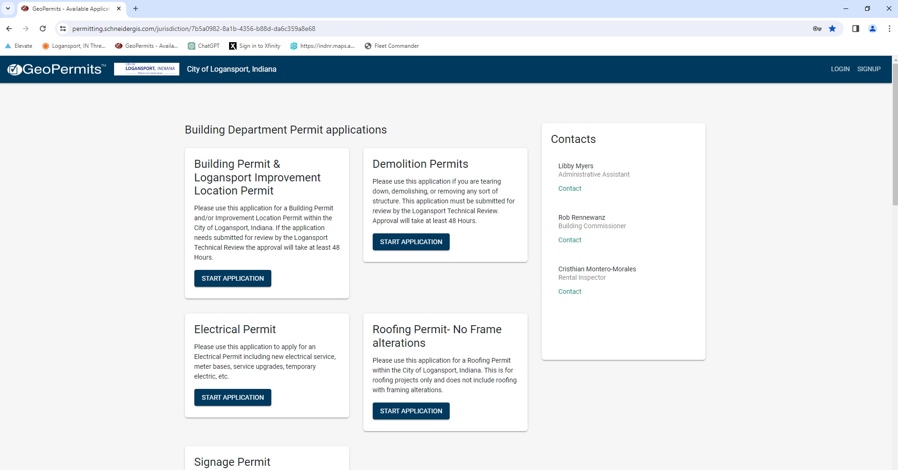

- Scroll all the way down to the bottom of the page and click “Start Application” in the box labeled “Contractors Registration”
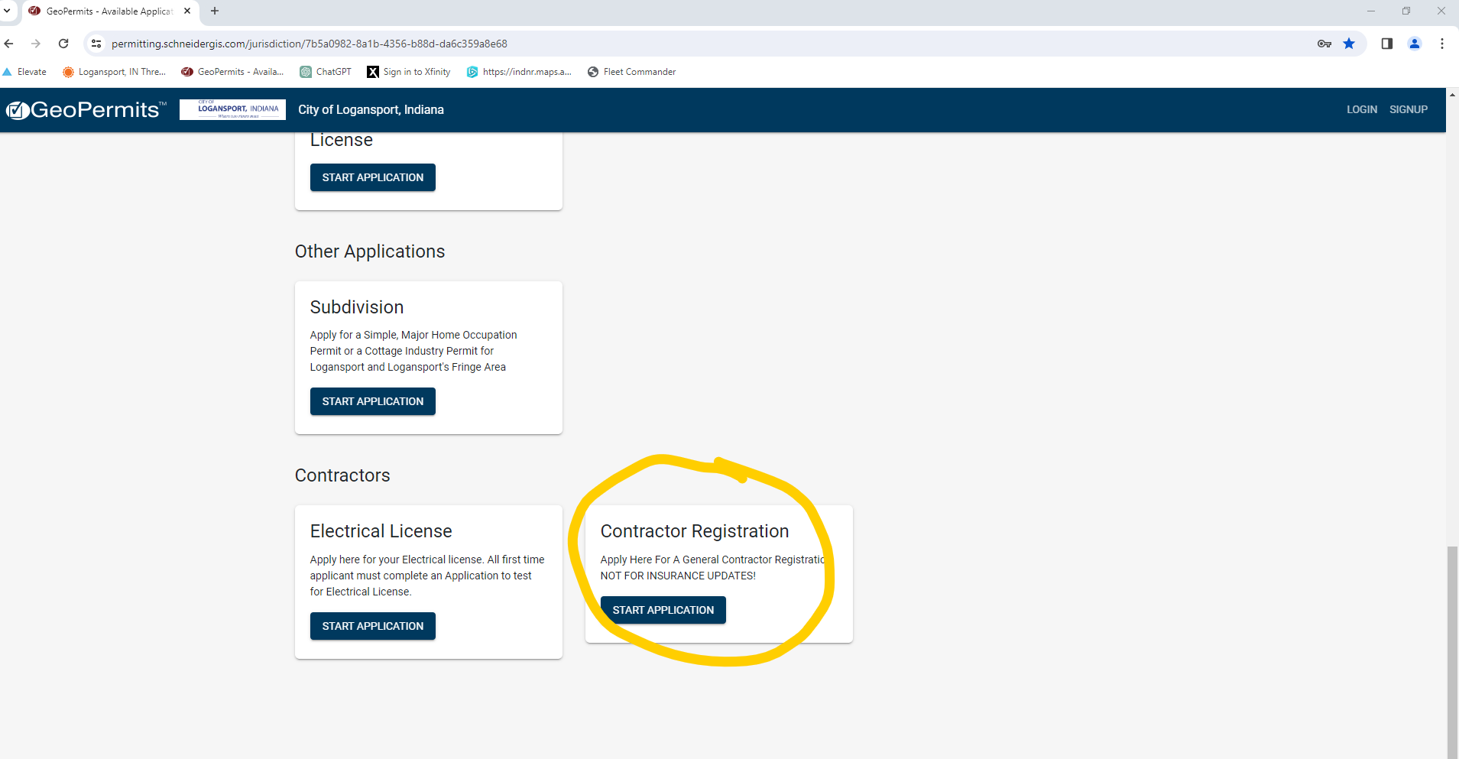
- You will be required to create an account
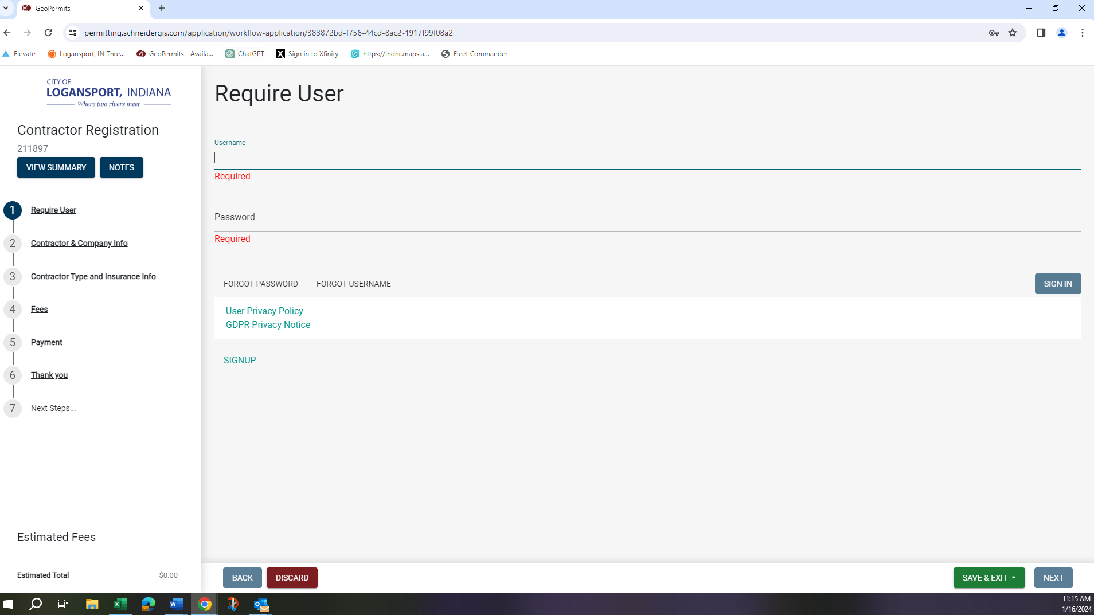
- You will need a Certificate of Liability with the
City of Logansport 601 E Broadway STE 303 Logansport, IN 46947
Listed in the certificate holder box.
- Complete all questions that pertain to your business and click next at the bottom of the screen. Payments can be made online (with a $1 convenience fee) by mailing a check to the office, or by cash brought into the office.
Please note Electricians should complete the Electrician’s License and NOT the Contractors Registration.
All payments are final!

