- Go to https://permitting.schneidergis.com/
- Login to the account in which the Contractors profile was created.
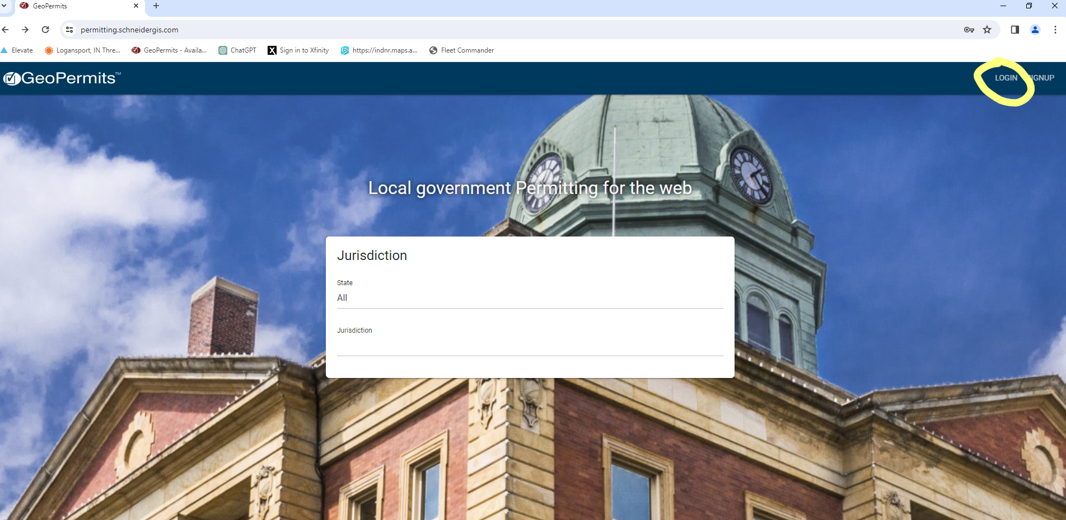
- Select Indiana under “state” and select City of Logansport under “jurisdiction” which will take you to the screen below.
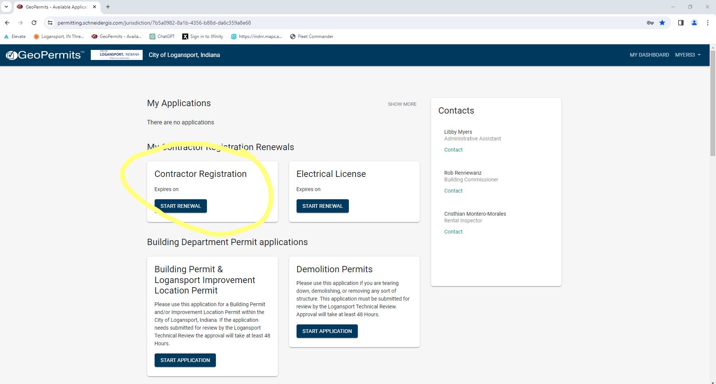
- Click “Start Renewal”.
- You will need your Certificate of Liability with the
City of Logansport 601 E Broadway STE 303 Logansport, IN 46947
in the certificate holder box.
- Complete all questions that pertain to your business and click next at the bottom of each screen.
- Payments can be made online (with a $1 convenience fee), by mailing a check to the office, or by cash brought into the office.

